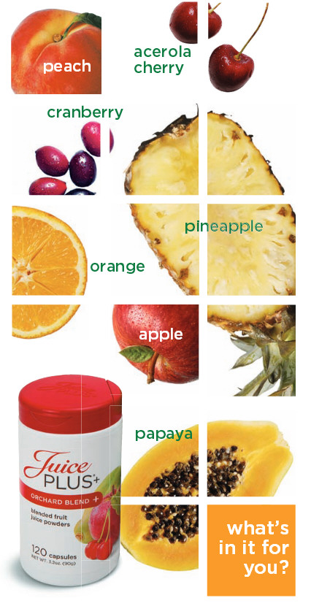
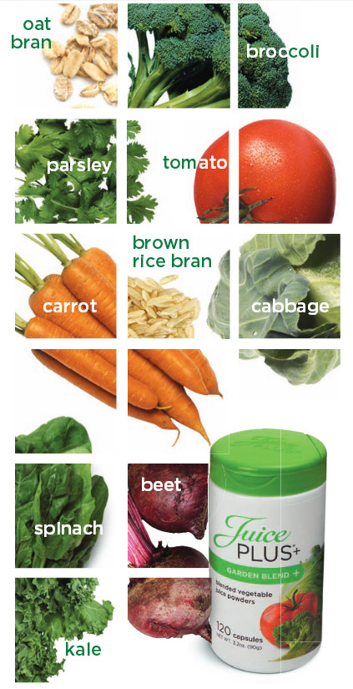
Juice Plus+ is 17 different raw fruits, vegetables and grains in capsules and delicious soft chewables. Juice Plus+ has been around more than 20 years; it is the most thoroughly researched nutritional product in history, and has been shown to:
- increase Anti-oxidants in the blood
- reduce Oxidation (free radical damage)
- normalize the Immune System
- protect/repair DNA
- improve Cardiovascular Wellness
- reduce Systemic Inflammation
- improve Gum Health
- improve Skin Health
- reduce symptoms of the Common Cold
- improve Athletic Recovery & Performance

It's convenient and inexpensive @ <$1.50 a day. Juice Plus+ is available free for children 4 to college age through our Children’s Health Study when an adult family member leads by example.

name, phone, email, website
Juice Plus+ is 17 different raw fruits, vegetables and grains in capsules and delicious soft chewables. Juice Plus+ has been around more than 20 years; it is the most thoroughly researched nutritional product in history, and has been shown to:
- increase Anti-oxidants in the blood
- reduce Oxidation (free radical damage)
- normalize the Immune System
- protect/repair DNA
- improve Cardiovascular Wellness
- reduce Systemic Inflammation
- improve Gum Health
- improve Skin Health
- reduce symptoms of the Common Cold
- improve Athletic Recovery & Performance

It's convenient and inexpensive @ <$1.50 a day. Juice Plus+ is available free for children 4 to college age through our Children’s Health Study when an adult family member leads by example.

name, phone, email, website

